System and Software Architecture Description (SSAD)
Improving Thai CDC
Establishing a New Client/Donor/Partner Communications & Project Tracking Tool

Team #: 01

Team Members & Roles
Name | Primary/Secondary Role
Brandon Foster | IIV & V/Quality Focal Point
Ding Li | Life Cycle Planner/Software Architect
Yi Li | Feasibility Analyst/Requirements Engineer
Ino Mantaring | Requirements Engineer/Prototyper
Vishal Punjabi | Operational Concept Engineer/Prototyper
Katelyn Swift-Spong | Manager/Operational Concept Engineer

12/05/2011

Version History
Date | Author | Version | Changes made | Rationale
10/10/2011 | Ding Li | 1.0 | - First version of SSAD, add description about purpose of SSAD and analysis of proposed system | - To analyze proposed system, identify context, artifact and behavior of proposed system.
10/14/2011 | Ding Li | 1.1 | - Updated UML model and fixed errors | - For Draft FCP
10/24/2011 | Ding Li | 2.0 | - Updated UMLs and fixed bugs.  Interoperability of NDIs is analyzed | - For Draft DCP
11/21/2011 | Ding Li | 3.0 | - Bugs fixed, UML updated, deployment diagram added | - Prepare for transition
12/05/2011 | Ding Li | 3.1 | - Bugs fixed | - For TRR

Table of Contents

System and Software Architecture Description (SSAD) i
Version History ii
Table of Contents iii
Table of Tables iv
Table of Figures vii
1. Introduction………………………………………………………………………………..1
2. System Analysis……………………………………………………………………………2
3. NDI/NCS Interoperability Analysis…………………………………………………….24

Table of Tables
Table 1: Actors Summary 2
Table 2: Artifacts and Information Summary 3
Table 3: Process Description: login 4
Table 4: Typical Course of Action-login: successfully 5
Table 5: Alternate Course of Action-login: failed 5
Table 6: Process Description: logout 5
Table 7: Typical Course of Action-logout: successfully 6
Table 8: Process Description: change password 6
Table 9: Typical Course of Action-change password: successfully 6
Table 10: Alternate Course of Action-change password: failed 6
Table 17: Process Description: view contacts information 7
Table 18: Typical Course of Action-view contacts information: success 7
Table 19: Alternate Course of Action-view contacts information: failed 7
Table 20: Process Description: add contact 8
Table 21: Typical Course of Action-add contact: successful 8
Table 22: Alternate Course of Action-add contact: failed 8
Table 23: Process Description: delete contacts 9
Table 24: Typical Course of Action-delete contacts: successful 9
Table 25: Alternate Course of Action-delete contact: failed 9
Table 26: Process Description: edit contacts information 9
Table 27: Typical Course of Action-edit contacts information: successful 10
Table 28: Alternate Course of Action-edit contacts information: failed 10
Table 29: Process Description: mass mail 10
Table 30: Typical Course of Action-mass mailing: successful 11
Table 31: Process Description: create newsletter format 11
Table 32: Typical Course of Action- create newsletter format: successful 11
Table 33: Process Description: add project 11
Table 34: Typical Course of Action-add project: successful 12
Table 35: Alternate Course of Action-add project: failed 12
Table 36: Process Description: delete project 12
Table 37: Typical Course of Action-delete project: successful 13
Table 38: Alternate Course of Action-delete project: failed 13
Table 39: Process Description: view project information 13
Table 40: Typical Course of Action-view project information: successful 14
Table 41: Alternate Course of Action-view project information: failed 14
Table 42: Process Description: edit project information 14
Table 43: Typical Course of Action-edit project information: successful 14
Table 44: Alternate Course of Action-edit project information: failed 15
Table 45: view donation information 15
Table 46: Typical Course of Action- view donation information: successfully 15
Table 47: Alternate Course of Action- view donation information: failed 16
Table 48: Process Description: add donation 16
Table 49: Typical Course of Action- add donation: successfully 16
Table 50: Alternate Course of Action- add donation: failed 16
Table 51: Process Description: add user 17
Table 52: Typical Course of Action-add user: successful 17
Table 53: Process Description: delete user 17
Table 54: Typical Course of Action-add worker: successful 18
Table 55: Process Description: edit user information 18
Table 56: Typical Course of Action-edit Data: successful 18
Table 57: Process Description: edit donation 19
Table 58: Typical Course of Action-edit donation: successful 19
Table 59: Alternate Course of Action- edit donation: failed 19
Table 60: Process Description: delete donation 20
Table 61: Typical Course of Action- delete donation: successful 20
Table 62: Alternate Course of Action- delete donation: failed 20
Table 63: Process Description: back up data 21
Table 64: Typical Course of Action- back up data: successful 21
Table 65: Process Description: filter donation 21
Table 66: Typical Course of Action- filter donation: successful 22
Table 67: Alternate Course of Action- filter donation: failed 22
Table 68: Process Description: filter project 22
Table 69: Typical Course of Action- delete donation: successful 22
Table 67: Alternate Course of Action- delete donation: failed 23
Table 71: Process Description: filter contacts 23
Table 66: Typical Course of Action- delete donation: successful 23
Table 67: Alternate Course of Action- delete donation: failed 23
Table 7: NDI Products Listing 24
Table 75: NCS Evaluation 24

Table of Figures
Figure 1: System Context Diagram 2
Figure 2: Artifacts and Information Diagram 3
Figure 3: Process Diagram 4

Introduction

Purpose of the SSAD
The System and Software Architecture Description (SSAD) describes the architecture of the entire system by analyzing the system's capability, content, artifacts, and behavior. It also explains/illustrates how NCSs/NDIs interact with one another.

Status of the SSAD
This is the second version of the SSAD document in TRR, version number 3.0. In this version, bugs of version 3.0 are fixed.

System Analysis

System Analysis Overview

The purpose of the Improving Thai CDC: Client/Donor/Partner Communications and Project Tracking Tool are to unify the contact list of each individual staff in Thai CDC and to provide a tool to monitor projects in Thai CDC. The Client/Donor/Partner Communications and Project Tracking Tool will provide a centralized database to manage contact information including contacts' names, addresses, donations and other information (as deemed fit by Thai CDC). The system will provide methods that add, edit, and delete contacts' information in a centralized cloud-based database. The system will also record information about each internal Thai CDC sponsored project, and it will provide tools to view the information about said projects.

System Context
Figure 1: System Context Diagram
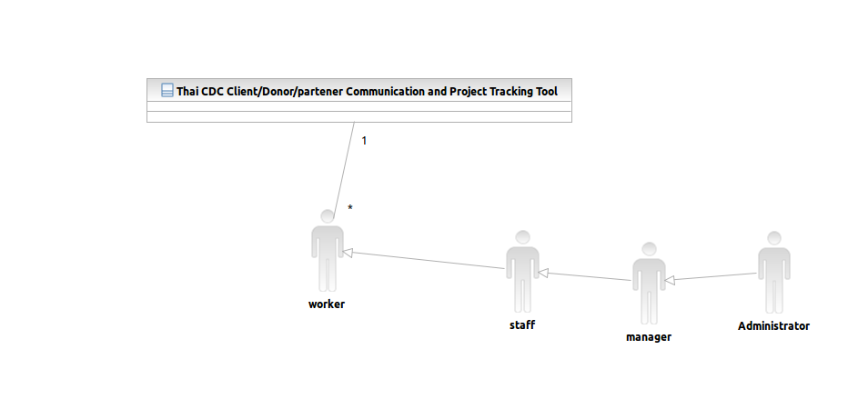

Table 1: Actors Summary
Actor | Description | Responsibilities
Staff | Staff of Thai CDC; Staff members are end-workers of the proposed system | Communicate with contacts, add contacts information into Salesforce. Send emails to contacts.
Manager | Managers are special staff, they are leaders of each project, they are in charge of the whole process of each project | Manage process of project
Administrator | Administrator can be an employee in Thai CDC or an outsourced technical  professional | Maintain the whole system
Worker (User) | Worker of the proposed system | Work with the system

Artifacts & Information
Figure 2: Artifacts and Information Diagram
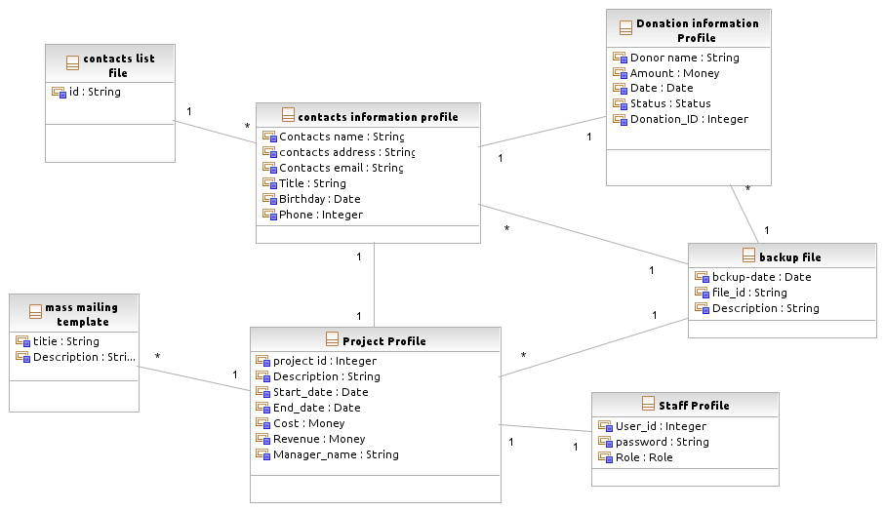
Table 2: Artifacts and Information Summary
Artifact | Purpose
ATF-1:contact information profile | A table in Salesforce which contains information about all contacts. The contacts' information is saved in Salesforce
ATF-2: mass mailing template | newsletters or email template files
ATF-3:project profile | A table in Salesforce whichContains all information about all projects in Thai CDC.
ATF-4: contact list file | Contact list file of MS outlook
ATF-5:staff profile | A table in Salesforce which contains information about all workers in proposed system
ATF-6: donation information profile | A Salesforce table to store the donation information
ATF-7:backup file | .csv files that exported from Salesforce, it includes all information in Salesforce

Behavior

Figure 3: Process Diagram
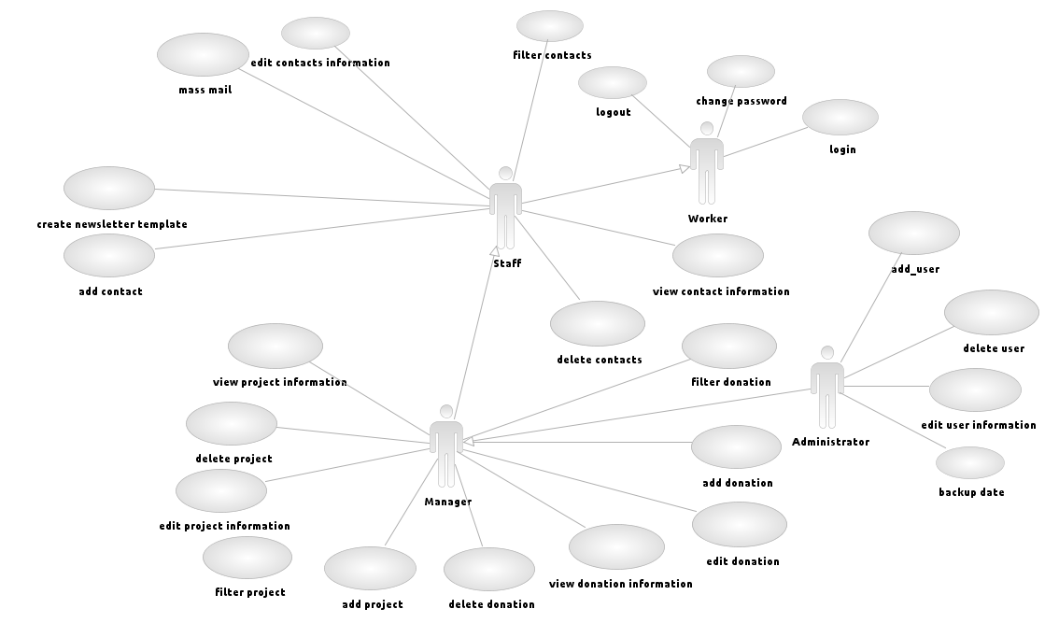

Contacts management

Login
Table 3: Process Description: login
Identifier | UC-1 login
Purpose | Worker log in the system. Check their password and authority
Requirements | WC_987:support at least 10 workers,
Development Risks | None
Pre-conditions | Data initialized in Salesforce
Post-conditions | Worker log into system if he/she type in worker name and password correctly, or he/she will be blocked.

Table 4: Typical Course of Action-login: successfully
Seq# | Actor’s Action | System’s Response
1 | [Worker] type in user name
2 | [Worker] type in password
3 |  | check username and password
4 |  | Approval worker's request
5 |  | Jump to worker's homepage(worker interface)
Table 5: Alternate Course of Action-login: failed
Seq# | Actor’s Action | System’s Response
1 | [Worker] type in user name
2 | [Worker] type in password
3 |  | check username and password
4 |  | Find worker name or password is incorrect
5 |  | Block worker's request

Logout

Table 6: Process Description: logout
Identifier | UC-2 logout
Purpose | Worker log out system
Requirements | WC_987:support at least 10 workers,
Development Risks | None
Pre-conditions | Data initialized in Salesforce, user login as worker
Post-conditions | Worker log out system.

Table 7: Typical Course of Action-logout: successfully
Seq# | Actor’s Action | System’s Response
1 | [Worker] click "logout" button
2 |  | Worker leave his/her homepage

Change password
Table 8: Process Description: change password
Identifier | UC-3 change password
Purpose | Worker change his/her password
Requirements | WC_987:support at least 10 users
Development Risks | None
Pre-conditions | Data initialized in Salesforce, user login as worker
Post-conditions | Worker's (staff of Thai CDC) password changed

Table 9: Typical Course of Action-change password: successfully
Seq# | Actor’s Action | System’s Response
1 | [Worker] click "change password" button
2 |  | Send a link to worker's e-mail box registered in Salesforce
3 | [Worker] Click the link
4 |  | Ask worker type in new password
5 | [Worker] Type in new password
6 | [Worker] Re-type new –password
7 |  | Change worker's password

Table 10: Alternate Course of Action-change password: failed
Seq# | Actor’s Action | System’s Response
1 | [Worker] click "change password" button
2 |  | Send a link to worker's e-mail box registered in Salesforce
3 | [Worker] Do nothing
4 |  | Time out

View contacts information
Table 11: Process Description: view contacts information
Identifier | UC-4 view contacts information
Purpose | Display contacts information in Salesforce to staff
Requirements | WC_197:categorize contacts,WC_959:deal with 4000 contacts
Development Risks | None
Pre-conditions | Data initialized in Salesforce, user login as staff
Post-conditions | Display contacts information to worker

Table 12: Typical Course of Action-view contacts information: success
Seq# | Actor’s Action | System’s Response
1 | [Staff] select a contact
2 | [Staff] click view button
3 |  | check staff’s authority
4 |  | worker’s authority approved
5 |  | Display information of selected contact to staff

Table 13: Alternate Course of Action-view contacts information: failed
Seq# | Actor’s Action | System’s Response
1 | [Staff] select a contact
2 | [Staff] click view button
3 |  | check staff’s authority
4 |  | staff’s authority refused

Add contacts
Table 14: Process Description: add contact
Identifier | UC-5 add contacts
Purpose | Add new contacts into Salesforce
Requirements | WC_197:categorize contacts, WC_959:deal with 4000 contacts
Development Risks | None
Pre-conditions | Data initialized in Salesforce, user login as staff
Post-conditions | New contacts added into Salesforce

Table 15: Typical Course of Action-add contact: successful
Seq# | Actor’s Action | System’s Response
1 | [Staff] click "new-contact" button
2 |  | Display a text filed for input
3 | [Staff] type in information of new contacts(contact id and so on)
4 | [Staff]Click submit
5 |  | check staff’s authority
6 |  | staff’s authority approved
7 |  | add contacts into Salesforce

Table 16: Alternate Course of Action-add contact: failed
Seq# | Actor’s Action | System’s Response
1 | [Staff] click "new-contact" button
2 |  | Display a text filed for input
3 | [Staff] type in information of new contacts(contact id and so on)
4 | [Staff]click submit
5 |  | check staff’s authority
6 |  | staff’s request refused due to lack of authority

Delete contacts

Table 17: Process Description: delete contacts
Identifier | UC-6 delete contacts
Purpose | Delete contacts from Salesforce
Requirements | WC_959:deal with 4000 contacts, WC_197:categorize contacts,
Development Risks | None
Pre-conditions | Data initialized in Salesforce, user login as staff
Post-conditions | contacts delete from Salesforce
Table 18: Typical Course of Action-delete contacts: successful
Seq# | Actor’s Action | System’s Response
1 | [Staff] click contact's id
2 | [Staff] click "delete" button
3 |  | Pop a confirm information
4 | [Staff] confirm request
5 |  | check staff’s authority
6 |  | staff’s authority approved
7 |  | delete contacts from Salesforce
Table 19: Alternate Course of Action-delete contact: failed
Seq# | Actor’s Action | System’s Response
1 | [Staff] click contact's id
2 | [Staff] click "delete" button
3 |  | Pop a confirm information
4 | [Staff] confirm request
5 |  | check staff’s authority
6 |  | staff’s authority refused

Edit contacts information
Table 20: Process Description: edit contacts information
Identifier | UC-7 edit contacts information
Purpose | Edit contacts information in Salesforce
Requirements | WC_959:deal with 4000 contacts, WC_197:categorize contacts,
Development Risks | None
Pre-conditions | Data initialized in Salesforce, user login as staff
Post-conditions | contacts information updated in Salesforce
Table 21: Typical Course of Action-edit contacts information: successful
Seq# | Actor’s Action | System’s Response
1 | [Staff] click contact's id
2 | [Staff] click "edit" button
3 |  | Display a text field for input
4 | [Staff] type in contact's new information
5 |  | check worker’s authority
6 |  | worker’s authority approved
7 |  | update contact's information in Salesforce
Table 22: Alternate Course of Action-edit contacts information: failed
Seq# | Actor’s Action | System’s Response
1 | [Staff] click contact's id
2 | [Staff] click "edit" button
3 |  | Display a text field for input
4 | [Staff] type in contact's new information
5 |  | check worker’s authority
6 |  | worker’s authority refused

Mass mail
Table 23: Process Description: mass mail
Identifier | UC-8 mass mail
Purpose | Send emails to large number of contacts
Requirements | WC_201 Integrate mass-mailing with Microsoft Outlook WC_205 System has mass-mailing capability
Development Risks | None
Pre-conditions | Data initialized in Salesforce, user login as staff
Post-conditions | Emails send to contacts

Table 24: Typical Course of Action-mass mailing: successful
Seq# | Actor’s Action | System’s Response
1 | [Staff] click mass mailing tab
2 |  | Display contacts list, format list
3 | [Staff] select contacts
4 | [Staff] select format and input email content
5 | [Staff] click "send" button
6 |  | send emails to contacts

Create newsletter format
Table 25: Process Description: create newsletter format
Identifier | UC-9 create newsletter format
Purpose | Create format for mass mailing
Requirements | WC_200 At least five template in system, WC_205 System has mass-mailing capability
Development Risks | None
Pre-conditions | Data initialized in Salesforce, user login as staff
Post-conditions | Template stored in system
Table 26: Typical Course of Action- create newsletter format: successful
Seq# | Actor’s Action | System’s Response
1 | [Staff] click new format button
2 |  | Display a new format input box
3 | [Staff] type in template
4 | [Staff] click submit
5 |  | Store template

Add project
Table 27: Process Description: add project
Identifier | UC-10 add project
Purpose | Manager add a project in Salesforce
Requirements | WC_198 system should have project tracking ability with all fields required by clients
Development Risks | None
Pre-conditions | Data initialized in Salesforce, user login as manager
Post-conditions | Project added into Salesforce

Table 28: Typical Course of Action-add project: successful
Seq# | Actor’s Action | System’s Response
1 | [Manager] click "add project" button
2 |  | Display a text field
3 | [Manager] type in project information
4 | [Manager] click "submit" button
5 |  | Check the authority of manager
6 |  | Manager authority approval
7 |  | add new project into Salesforce

Table 29: Alternate Course of Action-add project: failed
Seq# | Actor’s Action | System’s Response
1 | [Manager] click "add project "button
2 |  | Display a text input field
3 | [Manager] type in project information
4 | [Manager] click "submit" button
5 |  | Check the authority of manager
6 |  | Manager authority refused
7 |  | Refuse manager's request

Delete project
Table 30: Process Description: delete project
Identifier | UC-11 delete project
Purpose | Manager delete a project from Salesforce
Requirements | WC_198 system should have project tracking ability with all fields required by clients
Development Risks | None
Pre-conditions | Data initialized in Salesforce, user login as manager, user is on project page
Post-conditions | Project deleted form Salesforce

Table 31: Typical Course of Action-delete project: successful
Seq# | Actor’s Action | System’s Response
1 | [Manager] select a project
2 | [Manager] click "delete" button
3 |  | Pop a confirm information
4 | [Manager] confirm
5 |  | Check the authority of manager
6 |  | Manager authority approval
7 |  | delete project from Salesforce
Table 32: Alternate Course of Action-delete project: failed
Seq# | Actor’s Action | System’s Response
1 | [Manager] select a project
2 | [Manager] click "delete" button
3 |  | Pop a confirm information
4 | [Manager] confirm
5 |  | Check the authority of manager
6 |  | Authority refused
7 |  | Refuse request

View project information
Table 33: Process Description: view project information
Identifier | UC-12 view project information
Purpose | Manager track projects' information in Salesforce
Requirements | WC_198 system should have project tracking ability with all fields required by clients
Development Risks | None
Pre-conditions | Data initialized in Salesforce, user login as manager
Post-conditions | Project information displayed to manager

Table 34: Typical Course of Action-view project information: successful
Seq# | Actor’s Action | System’s Response
3 | [Manager] select a project
4 | [Manager] click "view project" button
6 |  | Check the authority of manager
7 |  | Manager authority approved
9 |  | display information of the project
Table 35: Alternate Course of Action-view project information: failed
Seq# | Actor’s Action | System’s Response
1 | [Manager] select a project
2 | [Manager] click "view project" button
3 |  | Check the authority of manager
4 |  | Manager authority refused

Edit project information
Table 36: Process Description: edit project information
Identifier | UC-13 edit project information
Purpose | Manager edit projects' information in Salesforce
Requirements | WC_198 system should have project tracking ability with all fields required by clients
Development Risks | None
Pre-conditions | Data initialized in Salesforce, user login as manager
Post-conditions | Project information updated form Salesforce

Table 37: Typical Course of Action-edit project information: successful
Seq# | Actor’s Action | System’s Response
2 | [Manager] select a project
4 | [Manager] click "edit project" button
5 |  | Display a text field for input
6 | [Manager] type in project information
7 | [Manager] click "submit" button
8 |  | Check the authority of manager
9 |  | Manager authority approvaled
10 |  | update project information
Table 38: Alternate Course of Action-edit project information: failed
Seq# | Actor’s Action | System’s Response
1 | [Manager] select a project
2 | [Manager] click "edit project" button
3 |  | Display a text field for input
4 | [Manager] type in project information
5 | [Manager] click "submit" button
6 |  | Check the authority of manager
7 |  | Manager authority refused

View donation information
Table 39: view donation information
Identifier | UC-14 view donation information
Purpose | Manager search information of donations
Requirements | WC_960 Implement a system that has fundraising abilities
Development Risks | None
Pre-conditions | Data initialized in Salesforce, user login as manager, user is on donation page
Post-conditions | Display donation information.

Table 40: Typical Course of Action- view donation information: successfully
Seq# | Actor’s Action | System’s Response
1 | [Manager] select a donation
2 |  | Check manager’s authority
3 |  | Approval manager’s request
4 |  | Display donation information
Table 41: Alternate Course of Action- view donation information: failed
Seq# | Actor’s Action | System’s Response
1 | [Manager] select a donation
2 |  | Check manager’s authority
3 |  | refuse manager’s request

Add donation

Table 42: Process Description: add donation
Identifier | UC-15 add donation
Purpose | Manager add a donation into Salesforce
Requirements | WC_960 Implement a system that has fundraising abilities
Development Risks | None
Pre-conditions | Data initialized in Salesforce, user login as manager
Post-conditions | Donation added into Salesforce

Table 43: Typical Course of Action- add donation: successfully
Seq# | Actor’s Action | System’s Response
1 | [manager] click add tab
2 |  | Display a text field for input
3 | [manager] type in donation information
4 | [manager] Click submit button
5 |  | Check manager’s authority
6 |  | Approval manager’s request
7 |  | Add donation to Salesforce

Table 44: Alternate Course of Action- add donation: failed
Seq# | Actor’s Action | System’s Response
1 | [manager] click add tab
2 |  | Display a text field for input
3 | [manager] type in donation information
4 | [manager] Click submit button
5 |  | Check manager’s authority
6 |  | refuse manager’s request

Add user
Table 45: Process Description: add user
Identifier | UC-16 add user
Purpose | Add new user into Salesforce
Requirements | WC_987 maintain at least 10 users
Development Risks | None
Pre-conditions | Data initialized in Salesforce, user login as administrator
Post-conditions | New user added into Salesforce

Table 46: Typical Course of Action-add user: successful
Seq# | Actor’s Action | System’s Response
1 | [Administrator] click user tab in his/her homepage
 |  | Display user list
3 | [Administrator] click "new-user" button
 |  | Display a text field for input
4 | [Administrator] type in information of new user(user id, password, email address and so on)
 | [Administrator]click submit
5 |  | add contacts into Salesforce

Delete user
Table 47: Process Description: delete user
Identifier | UC-17 delete worker
Purpose | Delete a worker from Salesforce
Requirements | WC_987 maintain at least 10 workers
Development Risks | None
Pre-conditions | Data initialized in Salesforce, user login as administrator
Post-conditions | Worker deleted from Salesforce

Table 48: Typical Course of Action-add worker: successful
Seq# | Actor’s Action | System’s Response
1 | [Administrator] click user tab in his/her homepage
2 |  | Display user list
3 | [Administrator] click a user’s id
4 | [Administrator] click "delete button"
5 |  | Pop a confirm information
6 | [Administrator] confirm
7 |  | delete worker from Salesforce

Edit user information
Table 49: Process Description: edit user information
Identifier | UC-18 edit user information
Purpose | Edit Data in Salesforce
Requirements | WC_987 maintain at least 10 users
Development Risks | None
Pre-conditions | Data initialized in Salesforce, user login as administrator
Post-conditions | Data updated in Salesforce
Table 50: Typical Course of Action-edit Data: successful
Seq# | Actor’s Action | System’s Response
1 | [Administrator] click user tab in his/her homepage
2 |  | Display user list
3 | [Administrator] click user’s id
4 | [Administrator] click "edit" button
5 |  | Display a text field for input
6 | [Administrator] type in user’s new information
7 | [Administrator]click submit
8 |  | Check administrator’s authority
9 |  | Approval authority
10 |  | update worker's information in Salesforce

Edit donation
Table 51: Process Description: edit donation
Identifier | UC-19 edit donation
Purpose | edit donation information in Salesforce
Requirements | WC_960 Implement a system that has fundraising abilities
Development Risks | None
Pre-conditions | Data initialized in Salesforce, user login as manager,
Post-conditions | donation information updated in Salesforce
Table 52: Typical Course of Action-edit donation: successful
Seq# | Actor’s Action | System’s Response
1 | [manager] click donation id
2 | [manager] click "edit" button
3 |  | Display a text field for input
4 | [manager] type in new information of donation
5 | [manager] click on submit
6 |  | Check manager’s authority
7 |  | Manager’s authority approved
8 |  | update donation information in Salesforce

Table 53: Alternate Course of Action- edit donation: failed
Seq# | Actor’s Action | System’s Response
1 | [manager] click donation id
2 | [manager] click "edit" button
3 |  | Display a text field for input
4 | [manager] type in new information of donation
5 | [manager] click on submit
6 |  | Check manager’s authority
7 |  | Manager’s authority refused

Delete donation
Table 54: Process Description: delete donation
Identifier | UC-20 delete donation
Purpose | delete donation information in Salesforce
Requirements | WC_960 Implement a system that has fundraising abilities
Development Risks | None
Pre-conditions | Data initialized in Salesforce, user login as manager
Post-conditions | donation information deleted from Salesforce
Table 55: Typical Course of Action- delete donation: successful
Seq# | Actor’s Action | System’s Response
1 | [manager] click donation id
2 | [manager] click "delete" button
3 |  | Pop a confirm information
4 | [manager] confirm
5 |  | Check manager’s authority
6 |  | Manager’s authority approved
7 |  | Delete donation in Salesforce

Table 56: Alternate Course of Action- delete donation: failed
Seq# | Actor’s Action | System’s Response
1 | [manager] click donation id
2 | [manager] click "delete" button
3 |  | Pop a confirm information
4 | [manager] confirm
5 |  | Check manager’s authority
6 |  | Manager’s authority refused

Back up data
Table 57: Process Description: back up data
Identifier | UC-21 back up data
Purpose | Edit Data in Salesforce
Requirements | WC_213: ability of exporting data
Development Risks | None
Pre-conditions | data initialized in Salesforce, user login as administrator
Post-conditions | Data exported from Salesforce
Table 58: Typical Course of Action- back up data: successful
Seq# | Actor’s Action | System’s Response
1 | [Administrator] click setup tab in his/her homepage
2 |  | Display setup page
3 | [Administrator] click backup button
4 |  | Start backing up data
5 |  | Send a link for downloading to administrator through email
6 | [Administrator] click the link in email and download backup files

Filter donation
Table 59: Process Description: filter donation
Identifier | UC-22 filter donation
Purpose | delete donation information in Salesforce
Requirements | WC_960 Implement a system that has fundraising abilities
Development Risks | None
Pre-conditions | Data initialized in Salesforce, user login as manager
Post-conditions | donation information displayed to manager
Table 60: Typical Course of Action- filter donation: successful
Seq# | Actor’s Action | System’s Response
1 | [manager] input filter conditions
2 | [manager] click "filter" button
3 |  | Check manager’s authority
4 |  | Manager’s authority approved
5 |  | Display donations which meet filter conditions

Table 61: Alternate Course of Action- filter donation: failed
Seq# | Actor’s Action | System’s Response
1 | [manager] input filter conditions
2 | [manager] click "filter" button
3 |  | Check manager’s authority
4 |  | Manager’s authority refused

Filter project
Table 62: Process Description: filter project
Identifier | UC-23 filter project
Purpose | delete donation information in Salesforce
Requirements | WC_198 system should have project tracking ability with all fields required by clients
Development Risks | None
Pre-conditions | Data initialized in Salesforce, user login as manager
Post-conditions | project information displayed to manager
Table 63: Typical Course of Action- delete donation: successful
Seq# | Actor’s Action | System’s Response
1 | [manager] input filter conditions
2 | [manager] click "filter" button
3 |  | Check manager’s authority
4 |  | Manager’s authority approved
5 |  | Display projects which meet filter conditions

Table 64: Alternate Course of Action- delete donation: failed
Seq# | Actor’s Action | System’s Response
1 | [manager] input filter conditions
2 | [manager] click "filter" button
3 |  | Check manager’s authority
4 |  | Manager’s authority refused

Filter contacts
Table 65: Process Description: filter contacts
Identifier | UC-24 filter contacts
Purpose | delete donation information in Salesforce
Requirements | WC_974 filter contacts
Development Risks | None
Pre-conditions | Data initialized in Salesforce, user login as manager
Post-conditions | contact information displayed to staff
Table 66: Typical Course of Action- delete donation: successful
Seq# | Actor’s Action | System’s Response
1 | [staff] input filter conditions
2 | [staff] click "filter" button
3 |  | Check manager’s authority
4 |  | Manager’s authority approved
5 |  | Display contacts which meet filter conditions

Table 67: Alternate Course of Action- delete donation: failed
Seq# | Actor’s Action | System’s Response
1 | [staff] input filter conditions
2 | [staff] click "filter" button
3 |  | Check manager’s authority
4 |  | Manager’s authority refused

NDI/NCS Interoperability Analysis

Introduction
Our project is a single NDI project. All of our functionalities are provided by Salesforce. All components such as Contacts Management Component, Mass Mailing Component and Project Tracking component are already connected with each others. So, it is needless to discuss the interoperability of these components.

COTS / GOTS / ROTS / Open Source / NCS
Table 68: NDI Products Listing
NDI/NCS Products | Purposes
Salesforce | Platform to provide all functionality in project

3.3 Connectors
We do not have any connectors because we have only one NCS

3.4 Legacy System
In this project, the system needs to import the data form MS Access, which is in .csv format.

System Structure

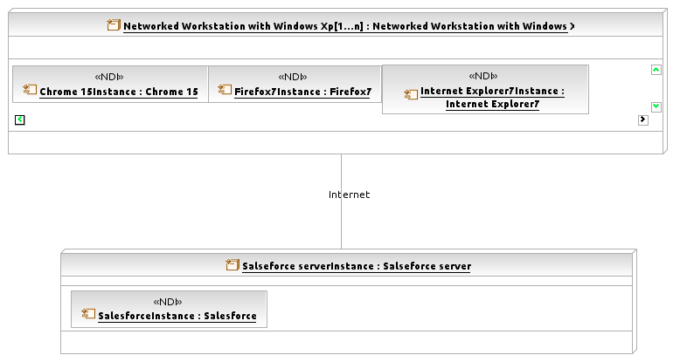
Figure 4: Deployment Diagram

Evaluation Summary
Table 69: NCS Evaluation
NDI | Usages | Comments
Salesforce | To provide all functionalities | It is the only NCS we used in our project

